Late Breaking Standard Tech
Omeed Dariani
Last weekend, the Wizards of the Coast Game Center, in Seattle, Washington, hosted a Challenge, which is a nonsanctioned event that Wizards employees can play. The format was Standard, with Invasion legal (no Saga Block) - the way that Standard will be played this weekend, at the Championships. Fattie Geddon won the tournament, in the hands of Ricky Boyes and was the second most-played deck, behind Void, which came in second, played by Elaine Chase. These decks are an excellent set of playtest decks and templates for this weekend's Championship.
Ricky Boyes, Fattie Geddon, Champion
Main Deck |  | Sideboard
4 Chimeric Idol  4 Armageddon  4 Parallax Wave  4 Tangle Wire  1 Wax/Wane  2 Disenchant  4 Birds of Paradise  4 Blastoderm  4 River Boa | 3 Llanowar Elves  3 Silt Crawler  1 Trained Armodon  4 Rishadan Port  4 Brushland  3 City of Brass  7 Forest  4 Plains | 3 Light of Day  3 CoP: Red  2 Creeping Mold  2 Uktabi Orangutan  1 Disenchant  2 Exile  2 Saproling Burst
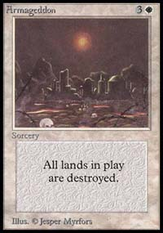
Ricky's deck is a typical Fattie Geddon deck. Using mana denial like Rishadan Port, Tangle Wire and Armageddon, Fattie Geddon wants to keep its opponent frustrated, while playing large creature threats like Blastoderm. Of note in Ricky's deck are the Silt Crawlers and Trained Armodon. Clearly, Noble Panther is a better option for the same cost - but Ricky could not find the Panthers in time, so he decided to use Armodons. Then, he could only find one Armodon! So, he had to play three of the marginally inferior Silt Crawler. The only real disadvantage of Ricky's creatures come in creature combat, where a Panther can use first strike to punch through. Parallax Wave and Chimeric Idol allow the deck to play around Perish, without losing any functionality. The sideboard is fairly standard, shoring the deck up in its weaker areas. More artifact/enchantment removal comes in to deal with opposing Idols and Waves, while Light of Day and Circle of Protection: Red are amazing color hosers. The Saproling Bursts out of the sideboard can be a huge threat against an unprepared deck. GW is a massive aggressive deck that can win any tournament - even through the threat of Perish. Watch for it to do well at States.

Elaine Chase, Void, Runner Up
Main Deck |  | Sideboard
4 Void  4 Shock  3 Hammer of Bogardan  4 Urza's Rage  4 Dark Ritual  4 Addle  1 Perish  2 Pyre Zombie | 1 Thrashing Wumpus  4 Blazing Specter  4 Skizzik  4 Urborg Volcano  4 Sulfurous Springs  8 Swamp  9 Mountain | 3 Cursed Totem  2 Marauding Knight  3 Tsabo's Web  3 Tsabo's Decree  3 Perish  1 Thrashing Wumpus
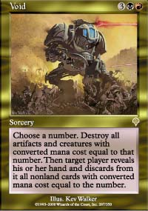
One of R&D's two newest acquisitions (the other being the amazing Brian Schneider), Elaine chose to play a powerful red/black deck that is a Wizards of the Coast favorite, and also played by R&D's William Jockusch, Henry Stern and Organized Play's Kierin Chase. Void is one of the most powerful spells in Invasion - and it gives R/B a major sweeper card, especially when combined with Addle. Blazing Specter is a huge threat creature that seems a lot more like Hypnotic Specter than Abyssal Specter. The real strength of Elaine's deck comes from it's recurring cards: Hammer of Bogardan and Pyre Zombie. Without a solid way to remove multiple spells from the game, most decks have a hard time fighting through the Hammer and Zombie. Hammer and Urza's Rage are very good answers to the 3/3 threats that Fattie Geddon presents. The deck's major weakness is Armageddon, which can just wreck it, since it needs so much mana to function. Thankfully, Dark Ritual speeds up the development, allowing for turn two Specter or turn three Void. When asked for revisions to this build, Elaine suggested taking out the Perish and adding another Thrashing Wumpus, as well as changing the sideboard, which is so slanted against G/W that it cannot sideboard all the cards in.

Robert Gutschera, 3rd, Rebels and Fatties
Main Deck |  | Sideboard
4 Parallax Wave  3 Wax/Wane  2 Reverent Mantra  1 Aura Mutation  4 Ramosian Sergeant  4 Fresh Volunteers  3 Steadfast Guard  1 Defiant Falcon  1 Thermal Glider  1 Lin Sivvi, Defiant Hero | 1 Stampede Driver  3 Thornscape Apprentice  4 Kavu Titan  2 Blastoderm  1 Llanowar Knight  2 Noble Panther  9 Plains  7 Forest  4 Brushland  2 Karplusan Forest  1 Elfhame Palace | 4 Armageddon  3 Wrath of God  2 Thermal Glider  2 Winnow  2 Aura Mutation  1 Reverent Mantra  1 Crimson Acolyte
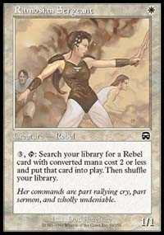
Robert's deck took a spin from Ben Rubin's PT-NY Rebel deck, which abandoned the overall rebel chain, opting instead to focus on the smaller rebels, primarily searching with Ramosian Sergeant. The key is to search out 2/2 rebels, like Fresh Volunteers and Steadfast Guard, and put some serious pressure on the opponent with big green creatures like Kavu Titan and Blastoderm. Robert's deck features several solid spells that help him maintain board control. Parallax Wave removes early blockers, allowing his rebels to punch through, while Reverent Mantra and Wax/Wane can save them from damage spells, or combine with Aura Mutation to remove troublesome enchantments. Though the two Karplusan Forests seem odd, for a deck with no red spells, they allow Robert to maximize the Thornscape Apprentices - and use Kavu Titan to kill Blastoderm without dying. Robert's sideboard has some cure-all spells, like Armageddon and Wrath, supplementing his removal with the underrated Winnow. Robert's deck is a very good adaptation of Fattie Geddon, which may be better in a Geddon-filled environment.

Joey Zappelli, 4th, Void
Main Deck |  | Sideboard
3 Void  4 Shock  2 Hammer of Bogardan  4 Urza's Rage  4 Dark Ritual  3 Addle  4 Chimeric Idol  2 Tsabo's Decree  1 Pyre Zombie | 2 Thrashing Wumpus  3 Blazing Specter  3 Abyssal Specter  4 Urborg Volcano  4 Sulfurous Springs  8 Swamp  8 Mountain  1 Keldon Necropolis | 3 Perish  1 Unmask  2 Spreading Plague  3 Massacre  2 Soul Burn  2 Overload  2 Pyre Zombie
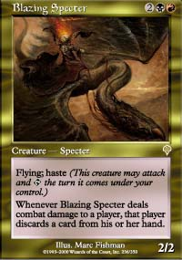
Joey's deck is very similar to Elaine's Void deck - it wants to accomplish the same things. Joey cut a few cards to make room for Chimeric Idol and Abyssal Specter, both of which are solid additions to the deck. There are a few points to address, though. Void is easily one of the most powerful spells in the deck - cutting down to three weakens the deck by decreasing the chances of actually drawing one. There are a lot of key differences in the sideboards. Elaine's is geared more towards the G/W matchup, while Joey's tries to cover more ground, with cards attacking several different strategies, from rebels to blue control.

Frank Chafe, 5th, Millstone
Main Deck |  | Sideboard
4 Power Sink  4 Counterspell  4 Absorb  4 Wrath of God  4 Millstone  4 Howling Mine | 4 Rethink  3 Rout  2 Enlightened Tutor  1 Boomerang  18 Island  8 Plains | 4 Wash Out  4 Disenchant  2 Teferi's Moat  1 Boomerang  1 Harsh Judgment  1 CoP: Green  1 CoP: White  1 CoP: Red
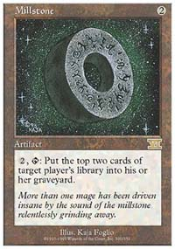
We haven't seen the likes of this since Pro Tour New York, '96 when Michael Loconto took the title with a U/W Millstone deck. Frank's deck tries to control the board with sixteen counterspells and seven Wrath effects. The win condition is created with Millstones and Howling Mines, which keep Frank drawing control cards. Enlightened Tutor helps get the early Mine into play, and makes sure that the sideboard enchantments factor into game two. Frank's sideboard has a lot of options that shut down burn and creature strategies. Even with the massive amount of control present in this deck, it can still just lose to Urza's Rage with kicker, making the Harsh Judgment in the sideboard a priceless enchantment. The Millstone strategy may be a solid one, but it is difficult to execute. Players who can manage the long game may find U/W a playable option at States.

Nancy Hu, 6th, Red/Green Beats
Main Deck |  | Sideboard
4 Tangle Wire  4 Rhystic Lightning  4 Shock  2 Hammer of Bogardan  4 Birds of Paradise  4 Llanowar Elves  4 River Boa | 4 Blastoderm  4 Maro  4 Skizzik  4 Rishadan Port  4 Shivan Oasis  4 Karplusan Forest  6 Forest  4 Mountain | 3 Earthquake  2 Tranquil Grove  2 Boil  3 Uktabi Orangutan  3 Kavu Chameleon  2 Creeping Mold
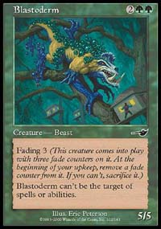
Nancy's deck is a fairly straightforward red/green beatdown deck. The strategy is to use burn spells to clear the path for big creatures. This is helped along by the mana creatures, Birds and Elves. Tangle Wire gives most decks a hard time, while allowing this one to continue applying pressure with a large threat like Maro or Blastoderm. Hammers of Bogardan give the deck some staying power against blue, in case bad things happen. The sideboard is spread out to deal with several decks - Kavu Chameleon is a good defense against blue decks and Perish, so it makes a lot of sense in the sideboard. Uktabi Orangutans are always a solid choice - it's surprising to see them in the sideboard, considering the number of Chimeric Idols and Tsabo's Webs in the other decks. Red/green is a good, offensive threat. Nancy's Top 8 proved that.

Charles Gordon, 7th, Blue/White Control
Main Deck |  | Sideboard
4 Blinding Angel  2 Jeweled Spirit  4 Wrath of God  3 Disenchant  3 Story Circle  4 Counterspell  4 Absorb  3 Foil | 4 Fact or Fiction  4 Brainstorm  1 Rath's Edge  1 Kor Haven  4 Coastal Tower  4 Adarkar Wastes  6 Plains  9 Island | 2 Teferi's Response  2 Misdirection  1 Disenchant  4 Chill  1 Rout  3 Submerge  2 Cursed Totem
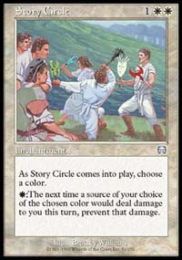
Charles Gordon built a classic blue/white deck. Using the card drawing effects of Brainstorm and Fact or Fiction, Charles was able to position himself in control of the game. Charles would often play a Story Circle, forcing his opponent to try and out-creature it, which he could easily prevent with Wrath of God. With eleven counterspells as support, it was difficult, if not impossible, for an aggressive deck to recover. Blinding Angel lends to this strategy, adding another way to prevent creatures from dealing damage to him, while serving as a slow damage source. Jeweled Spirit is a bigger threat, which acts a little like Morphling, with evasion and the self-preserving ability. The only way for an aggressive deck to get back into the game is Urza's Rage with kicker. Even then, Charles has the Absorb "trick" (where a player Absorbs the Rage to gain three life), and, after sideboarding, Chill and Misdirection, to stop or redirect Rage. Gordon also chose Teferi's Response over Tsabo's Web, opting for the brutal card advantage situation, over the continuous effect. Blue/white has been on the outs for awhile - with some refining, this deck could reemerge as a powerhouse.

Jed Dolbeer, 8th, Blue Skies
Main Deck |  | Sideboard
4 Spiketail Hatchling  4 Drake Hatchling  4 Troublesome Spirit  4 Cloudskate  4 Rishadan Airship  4 Thwart | 4 Foil  2 Daze  4 Brainstorm  2 Boomerang  2 Seal of Removal  22 Island | 4 Submerge  3 Chill  2 Boomerang  2 Waterfront Bouncer  4 Tangle Wire
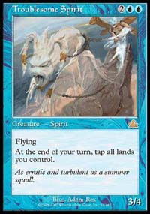
When uncertain, go with what you know. That's what Jed did, adapting a popular Masques Block deck for the new Standard environment. Blue Skies is all about racing, wagering that an opponent will not be able to deal with twenty powerful flying creatures. It's very difficult to beat this deck, without preparing for it. Blue Skies operates a lot like Fish - it likes to get a few threats into play and defend them, rather than focusing on replacing threats as they are removed. Spiketail Hatchling is an amazing momentum card, which keeps an opponent a turn behind for the rest of the game, unless he or she is willing to trade a spell for a 1/1 creature. The big guns, Troublesome Spirit and Rishadan Airship, can end the game in short order, especially with the free counter backup of Foil, Thwart and Daze. Jed's sideboard has some anti-green and some anti-red, along with several cards designed to enhance Skies against creature decks or control decks. Second turn Boomerang on an opponent's land is almost a win against control, with this deck. Blue Skies was a powerful force in MBC, and it should carry over to Standard, without much change. Fish has always been a good choice, in a field with both beatdown and control, and Blue Skies is a modern version of Fish.
Several other decks showed up at the Game Center Challenge, from Nether-Go (2-3) to Ankh-Tide (3-2, 2-2-1). The Top 8 at the Challenge included seven different deck types, with only Void being played by more than one Top 8 competitor. The field for the Championships will be very diverse and could see several new decks emerge. Next week, the Sideboard will report on the Championship decks. Good luck at States!
For more information about the Championships, click here.

